# Power BI Project Report : LEAN SIX SIGMA OPERATIONAL PROCESS CHARTS DASHBOARD

Prepared by: KARTHI RAJAN G

Date: 15/11/2024

## 1. Introduction

This report presents the analysis and visualizations developed using Power BI as part of the assigned project. The objective was to generate meaningful insights from Value Added (VA), Non-Value Added (NVA), and Sub Value Added (SVA) data sourced from six different sheets. The primary goal was to represent these insights through interactive and comprehensive charts, including Pareto and pie charts.

## 2. Project Overview

The project involved the following key tasks:  
- Calculating the total duration of VA, NVA, and SVA across multiple datasets.  
- Creating Pareto charts to highlight key contributors based on data distribution.  
- Designing pie charts and other visual representations to effectively communicate the data breakdown.  
- Handling time conversion challenges to ensure the duration data was accurately displayed.

## 3. Analysis and Results

### 3.1. Pareto Charts

Description:  
The Pareto charts illustrate the distribution of 'Description' values across six different tables, highlighting which tables contribute most significantly to the overall count.  
- X-Axis: Names of the six tables.  
- Y-Axis: Count of 'Description' values.  
- Key Insight: The Pareto principle was applied to identify areas with the most impact.  
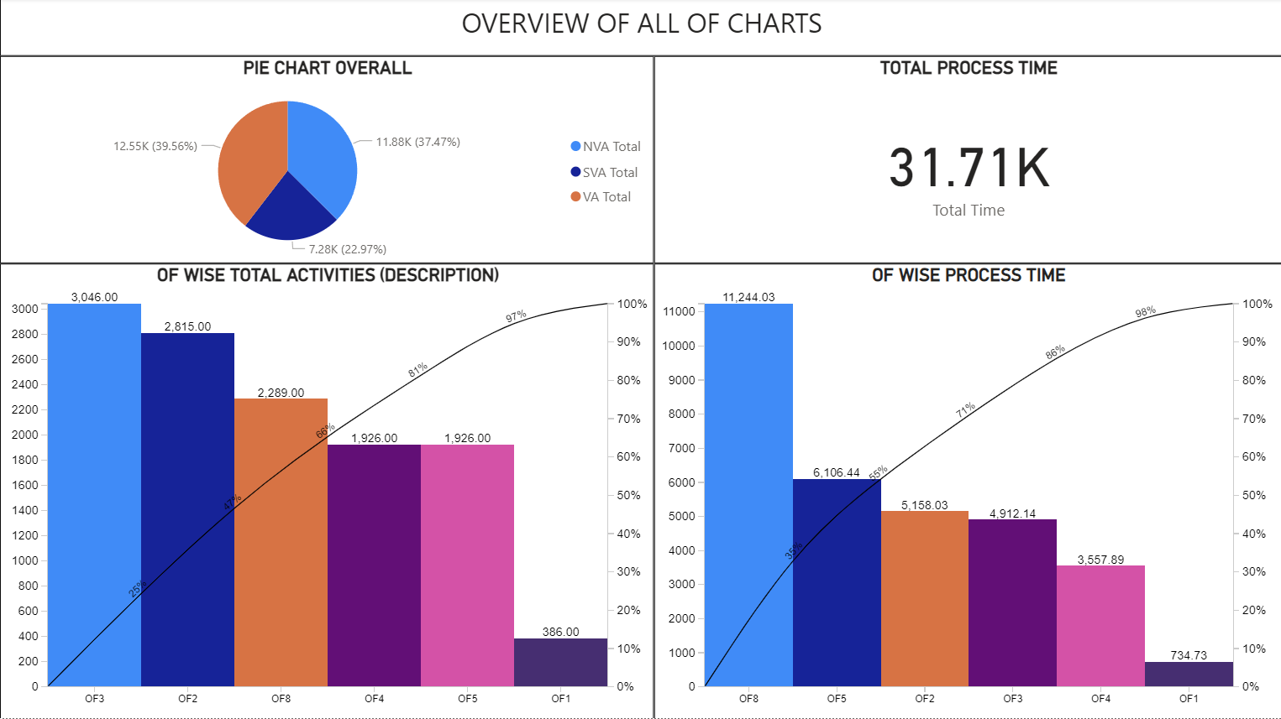

### 3.2. Pie Charts

Description:  
The pie charts provide a clear visualization of the VA, NVA, and SVA data distribution in decimal values.  
- Data Segmentation: The charts break down the proportions of VA, NVA, and SVA durations to highlight the areas needing improvement.  
  
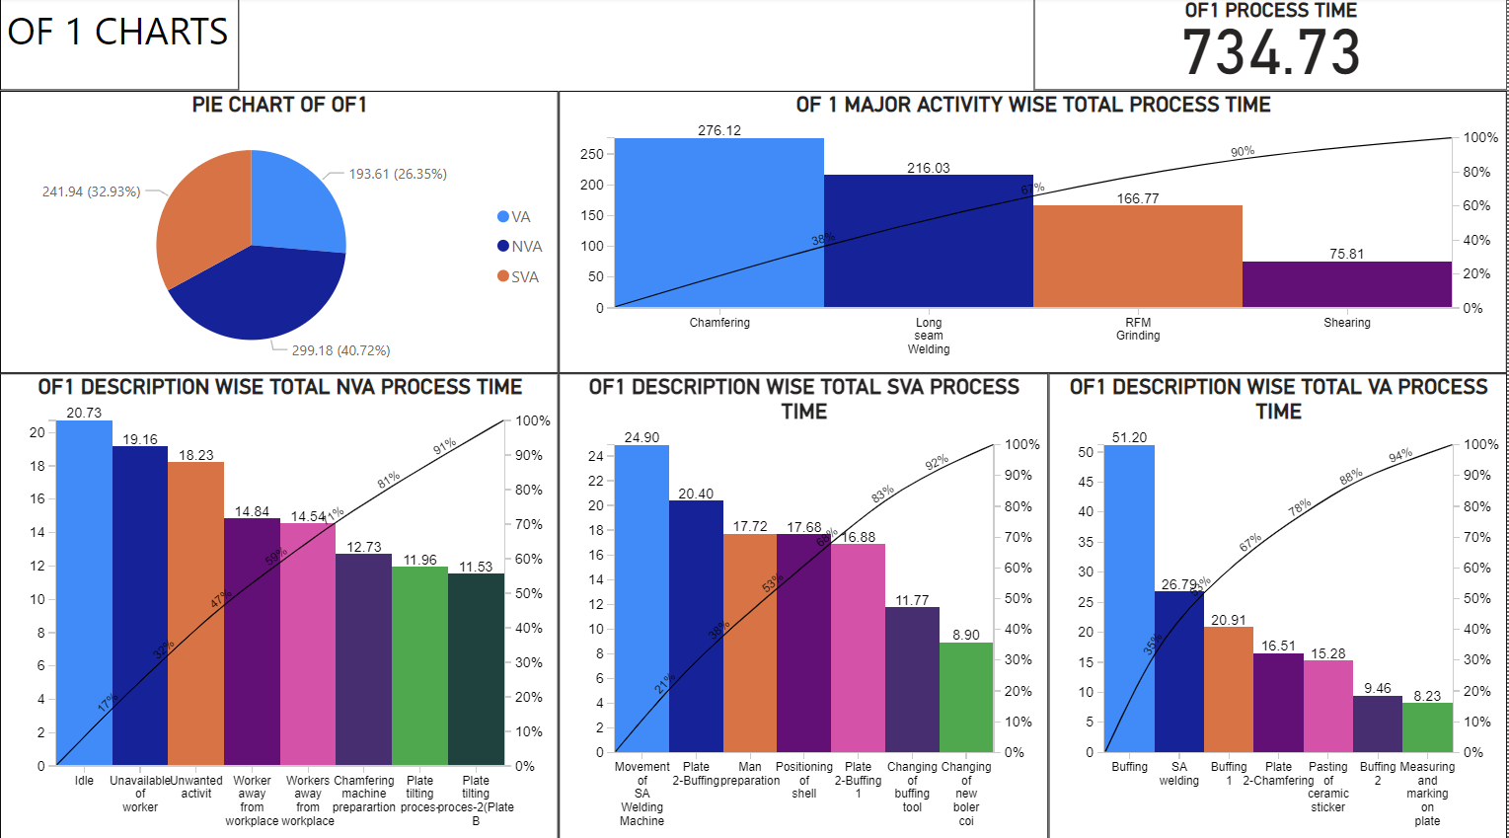

### 3.3. Additional Charts

Description:  
Other visualizations created include line graphs and bar charts that further analyze the VA, NVA, and SVA durations. These charts facilitate a comprehensive understanding of the patterns and trends in the dataset.

## 4. Challenges and Workarounds

One of the main challenges faced during this project was converting decimal values to a duration format (00:MM:SS). Power BI does not provide a straightforward conversion method, so an alternative approach was developed to approximate the desired format as closely as possible.

## 5. Conclusion

The Power BI project successfully visualizes key data insights, emphasizing areas for improvement through interactive and intuitive charts. The use of Pareto and pie charts effectively identifies significant contributors and breaks down complex data into understandable segments.  
  
Thank you for reviewing this report. Please feel free to share your feedback or suggestions.